**Copy the contents from the file commands.txt to commands_demo.txt**

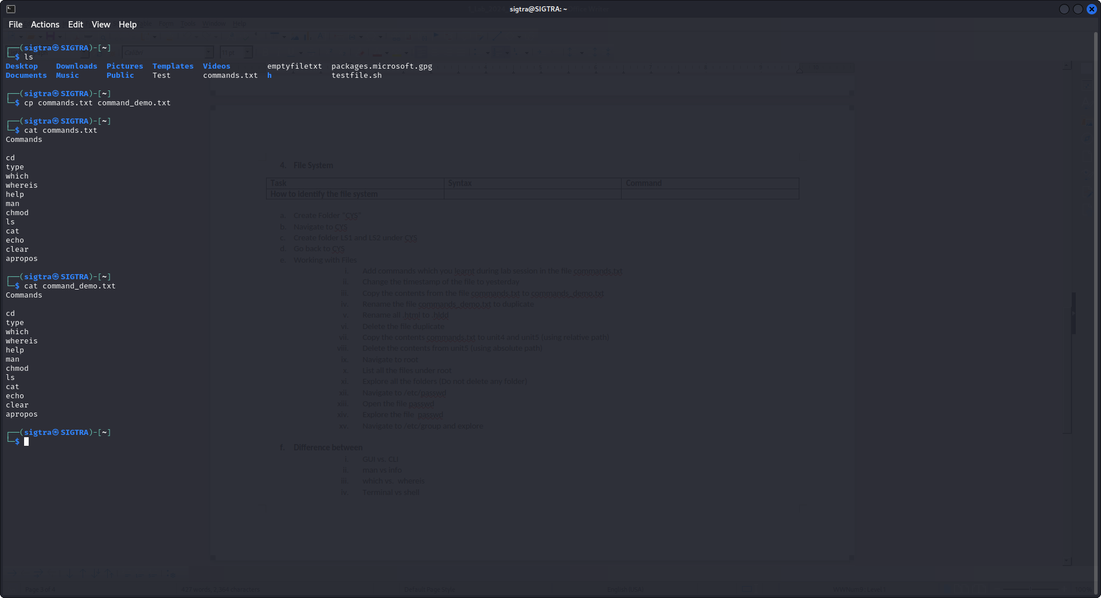

Change the timestamp of the file to yesterday

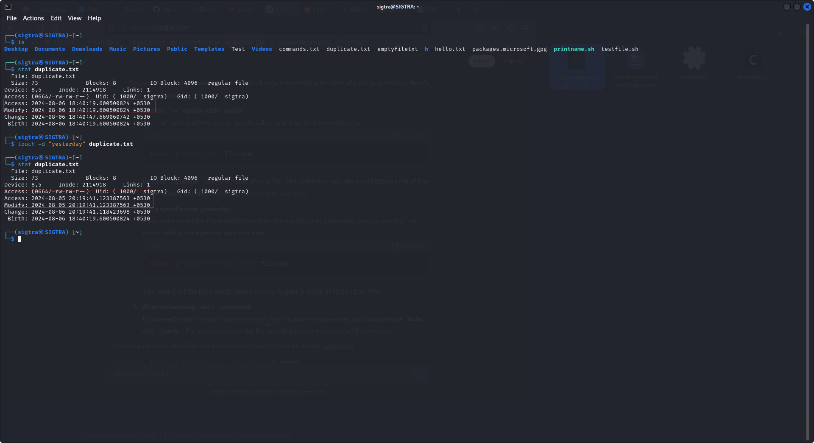

Rename the file commands_demo.txt to duplicate

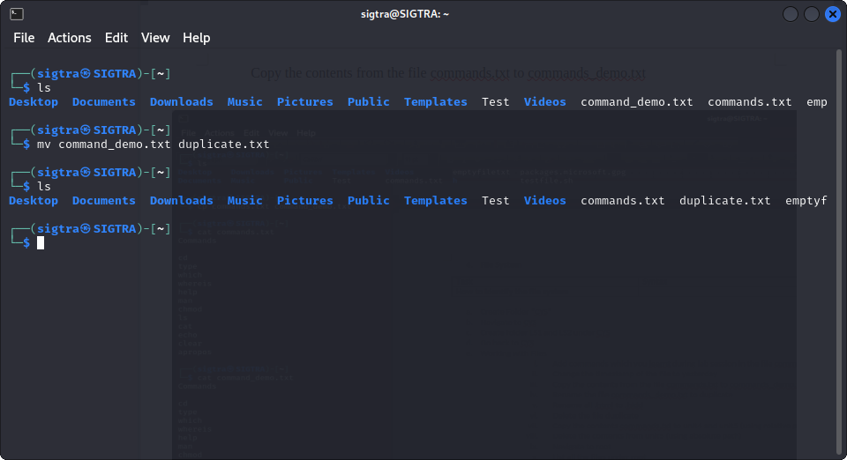

Rename all .html to .txt

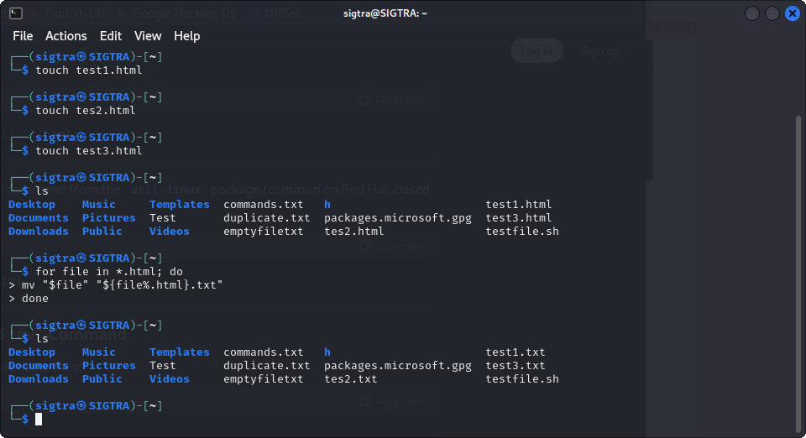

Navigate to root

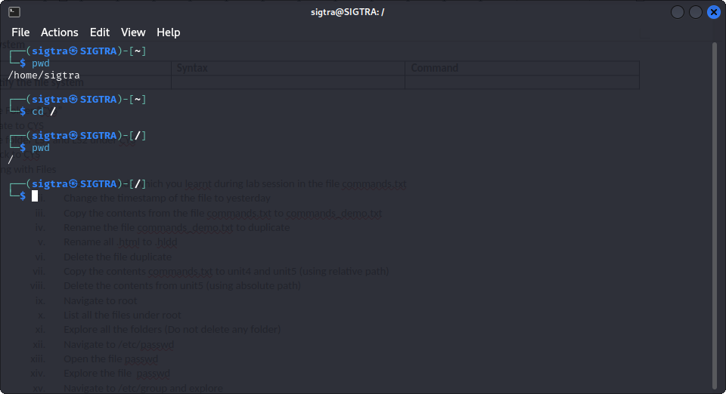

List all the files under root

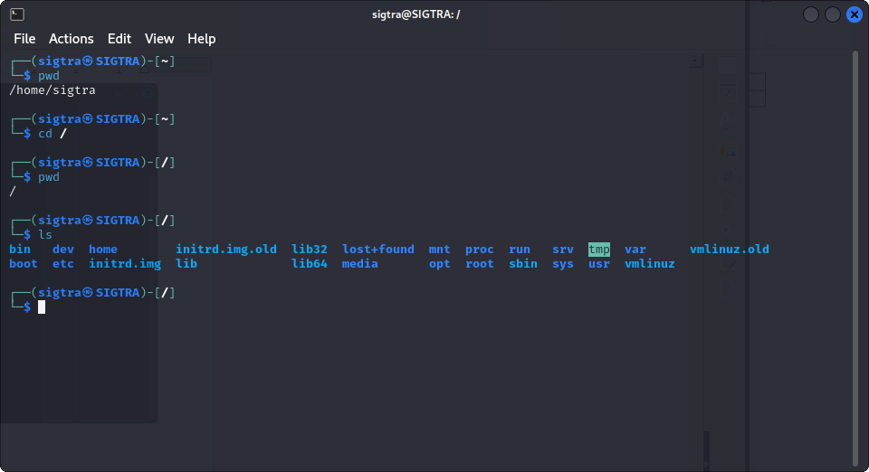

Open the password file and explore

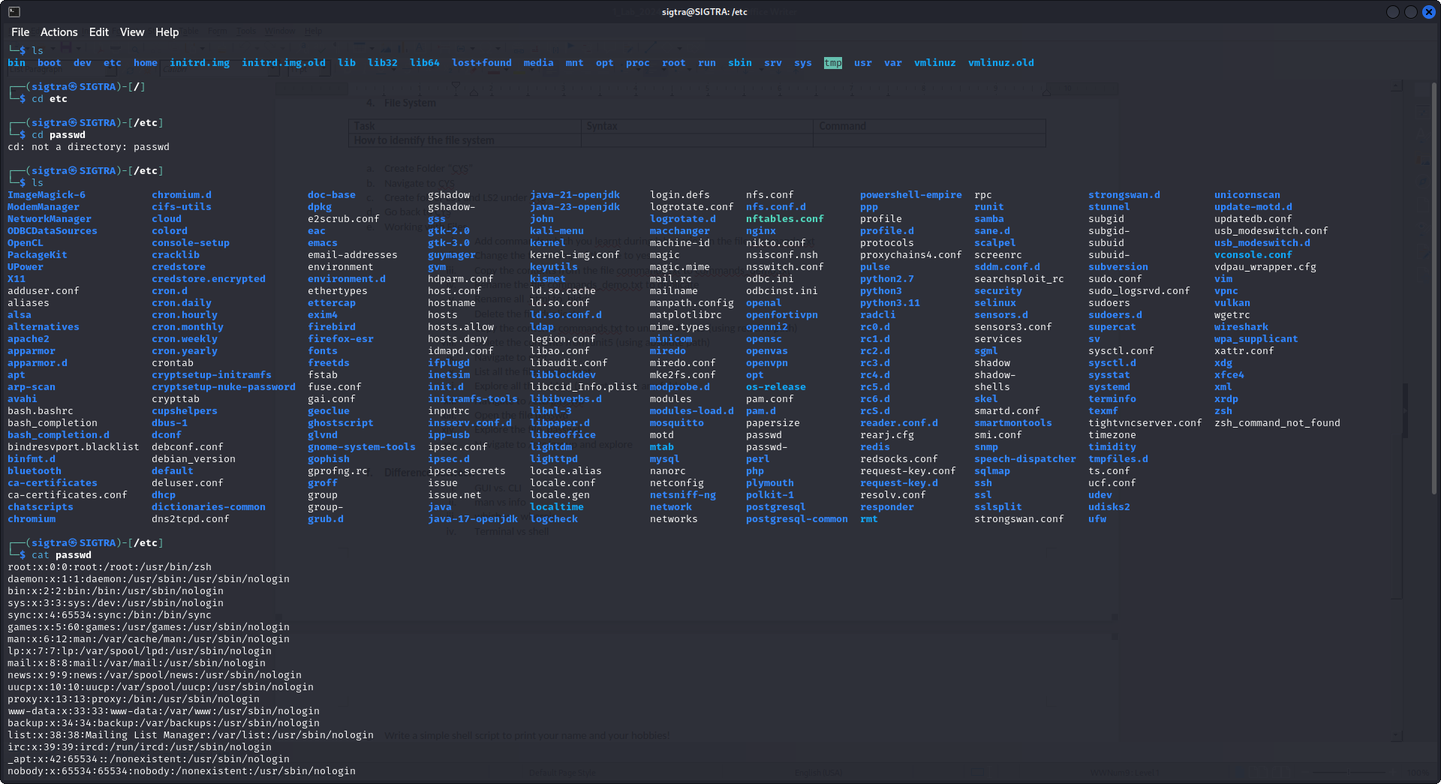

Navigate to /etc/group and explore

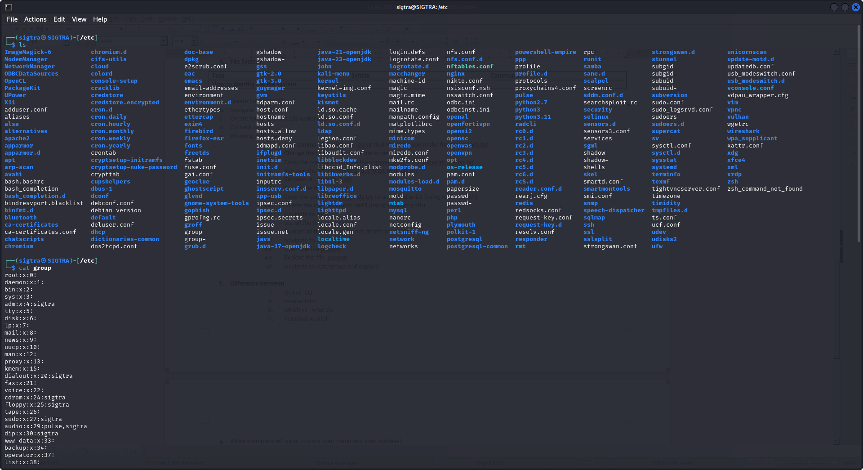

**Difference between**

1) CLI and GUI

|  |  |
| --- | --- |
| **CLI** | **GUI** |
| It is comparatively more difficult to understand and use. | It is comparatively easier to understand and use. |
| CLI consumes comparatively less memory. | The GUI consumes comparatively more memory. |
| Higher precision of work can be obtained using CLI. | GUI offers a lower level of precision. |
| It works at a higher speed as compared to the GUI. | It works at a much slower speed as compared to the CLI. |
| Its OS only requires a user’s keyboard. | Its OS requires both keyboard and mouse to work. |
| We cannot change or modify the CLI operating system’s appearance. | We can change or modify the GUI operating system’s appearance. |
| No graphs are included in CLI. | Graphics are always used in the GUI. |
| No menus are provided in CLI. | The GUI OS comes with menus. |
| The information that the user wants to view is displayed in files and plain text. | The information that the user wants to access is presented in various forms, like plain text, images, videos, gifs, videographs, etc. |
| The input is usually entered at the command prompt in CLI. | We can input the data anywhere on the computer screen in the case of GUI. |
| Pointing devices are not used at all in CLI. | We use pointing devices in the GUI for choosing/selecting the items we want to. |
| No typing errors or spelling mistakes can be avoided by CLI. | The typing errors or spelling mistakes cannot be avoided by the GUI. |

Man vs INFO

|  |  |
| --- | --- |
| **MAN** | I**NFO** |
| Focuses on providing concise, straightforward documentation. | Provides extensive, detailed documentation with more structure. |
| Uses a simple, sectioned format. | Supports hypertext navigation and more complex formatting |
| Best for quick look-ups and command references. | Supports hypertext navigation and more complex formatting. |

Terminal vs Shell

|  |  |  |
| --- | --- | --- |
| Feature | Terminal | Shell |
| **Definition** | A program that provides a user interface to interact with a computer system through text-based input and output. | A command interpreter program that enables users to interact with an operating system, executing commands and scripts. |
| **Function** | Provides a user interface to execute commands and applications on a computer system. | Executes commands and interprets scripts based on user input, providing an interface to interact with the operating system. |
| **User Interaction** | Users enter commands and receive text-based output as a response. | Users enter commands, and the shell interprets and executes them, providing feedback and results. |
| **Examples** | GNOME Terminal, macOS Terminal, Windows Terminal. | Bash, PowerShell, Zsh, Csh, Ksh, etc. |
| **Platform Dependence** | Terminal programs can be platform-specific but often have equivalents across different operating systems. | Shells can be specific to an operating system or have cross-platform implementations (e.g., Bash, PowerShell). |
| **Graphical Interface** | Terminal applications are typically text-based and do not have graphical user interfaces. | Shells are typically text-based and do not provide graphical user interfaces. |

Which vs whereis

|  |  |
| --- | --- |
| **Which** | **whereis** |
| If we want the path of binary that gets executed when a command is run in the shell, then we have to use which command | if you are looking for the source, binary, and man pages for a command, use whereis. |
| The which command only displays the first executable that gets executed when you type the said command in the shell. | The whereis command lists all the binary executables |
| The which command performs searches in the PATH variable | The which command performs searches in the PATH variable |

Create a bash file , and make it print name and your hobbies

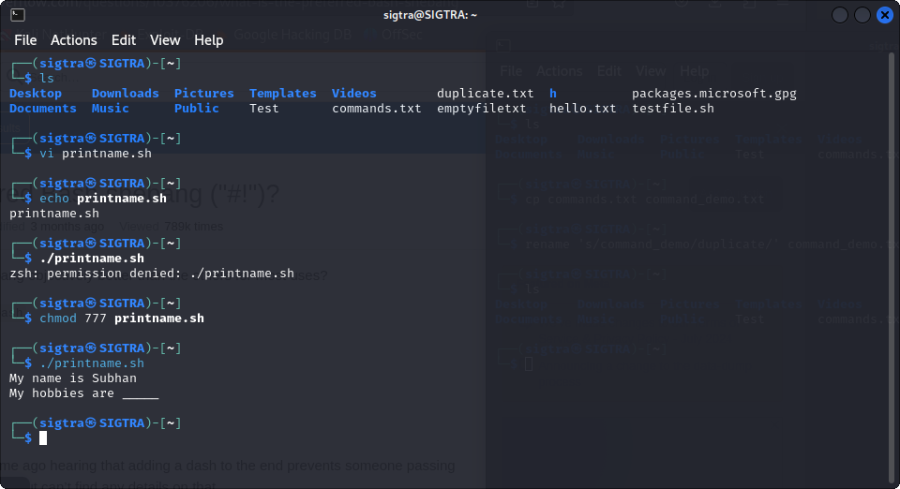

Banner command:

User to print the larger letter on terminal

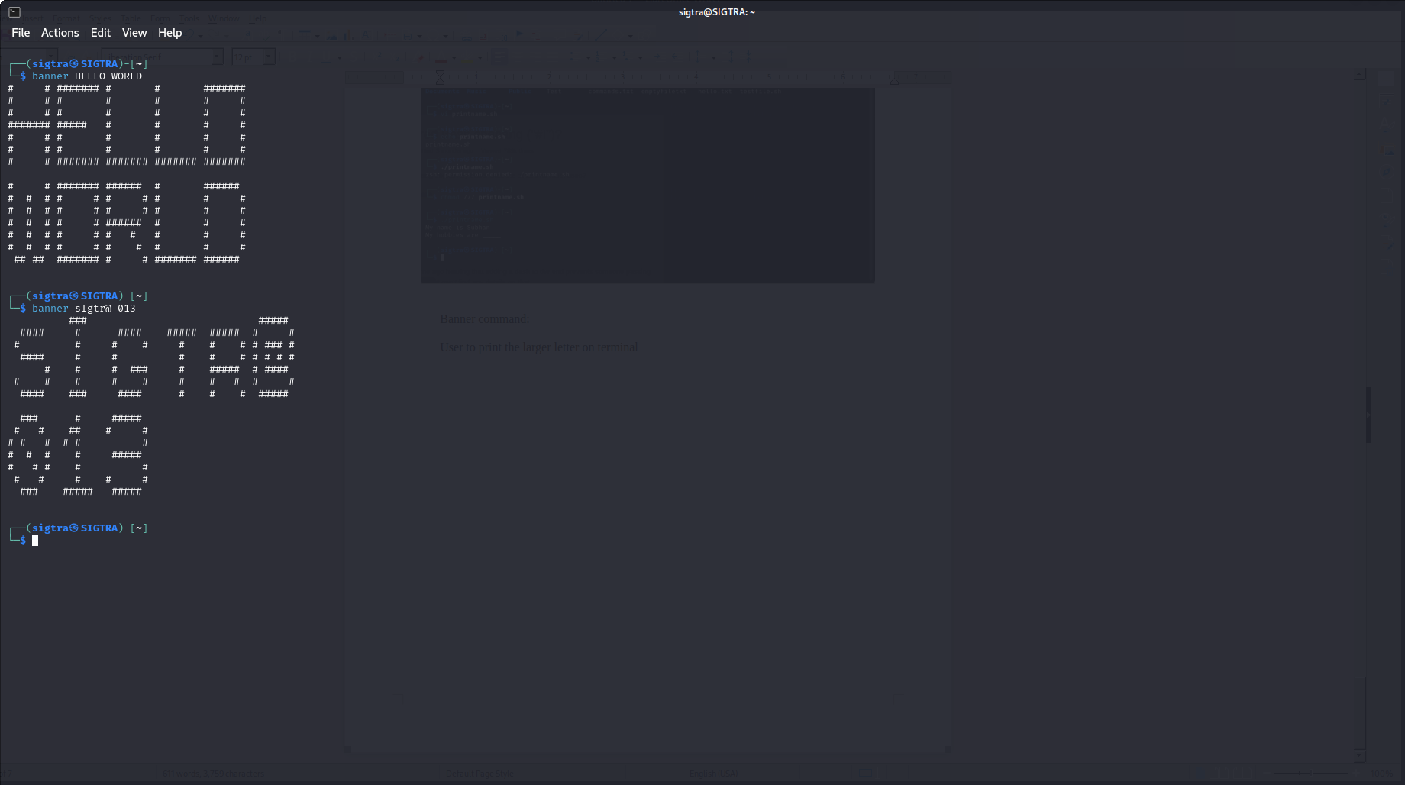

History command:

Keeps the history of the command that we typed in terminal from the beginning

